P.Keerthi

192011340

CSA0734- Computer Networks for Server Management

Experiment: 11

IOT Based Smart Home Using Cisco Packet Tracer

AIM:

IOT Based Smart Home Using Cisco Packet Tracer

REQUIREMENTS:

* Home Gateway
* Ceiling Fan
* Window
* Smart Phone
* Packet Tracer Software

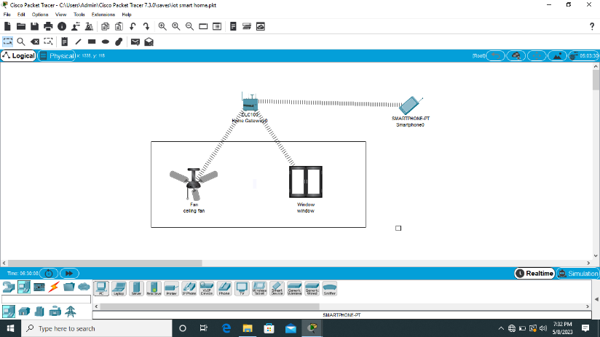

Result:

The configuration of a smart home using IOT is completed and verified successfully.